**Testing Reports**

This document is to summarise our testing.

Date: Wednesday 13th December 2023 AM

Tester: Romain and Millennia

Area of Testing: Log in Page

| **DECISION TABLE** | | | |  |
| --- | --- | --- | --- | --- |
| Email | Password | Expected Outcome/Assumptions | Observed Behavior | NOTES |
| Signed-up | Valid | Log in | User logs in and is redirected to the main page |  |
| Signed-up | Invalid | "Invalid email and/or password" error | Error message "Enter a valid email or password" | Suggest text modification to avoid ambiguity:  "Enter valid email and password" |
| Unknown | Valid | "Invalid email and/or password" error | Error message "Enter a valid email or password" |  |
| Unknown | Invalid | "Invalid email and/or password" error | Error message "Enter a valid email or password" |  |
| any | Blank | "Password cannot be blank" error | Error message "Enter a valid email or password" |  |
| Blank | any | "Email must be specified" error | Error message "Enter a valid email or password" |  |

Findings:

The show password works as intended. It show all characters and special character

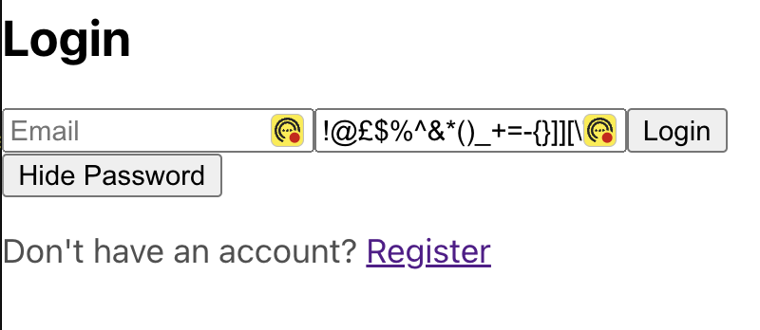

It also shows spaces

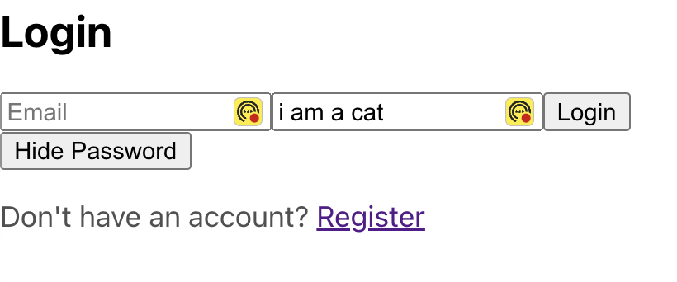

The hide word password works as intended

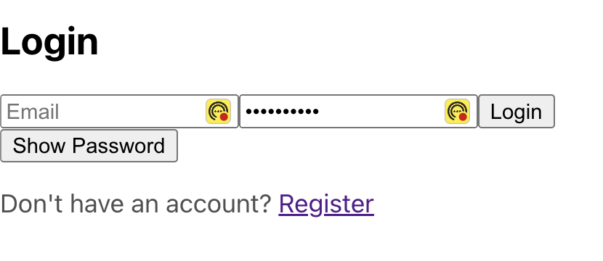

We have tested that it hides a password of at least 100 character - there seems to be no min or max to this function

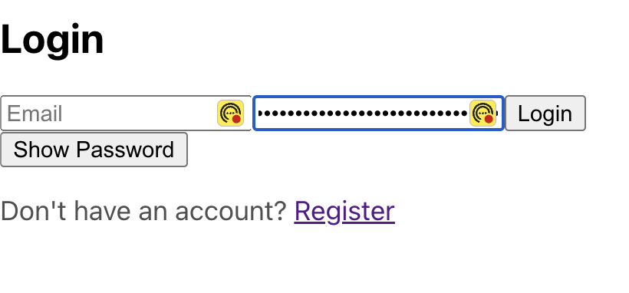

| **LOG IN** | | | |
| --- | --- | --- | --- |
| **Test cases** | **STATUS** | **ACTUAL** | **COMMENTS** |
| When I click on "Show password" when the password is hidden, the password is shown |  | Password is displayed |  |
| When I click on "Hide password" when the password is displayed, the password is hidden |  | Password is hidden |  |
| The Page title is "Log In" |  | Page Title is "React" | Suggest changes with " Log In" |
| Once logged in, creates and maintains a session for that user. |  | User session is maintained | However, the user can still access log in and sign up |
| Given a User is Logged In, when trying to access the Log In page again, the User is redirected to the Lobby |  | User is not automatically redirected to the lobby and can access the log in page whenever |  |

**Observations and Suggestions**

1. Consider changer the Page title to “Log in” to avoid confusion

At the moment it says “React App”

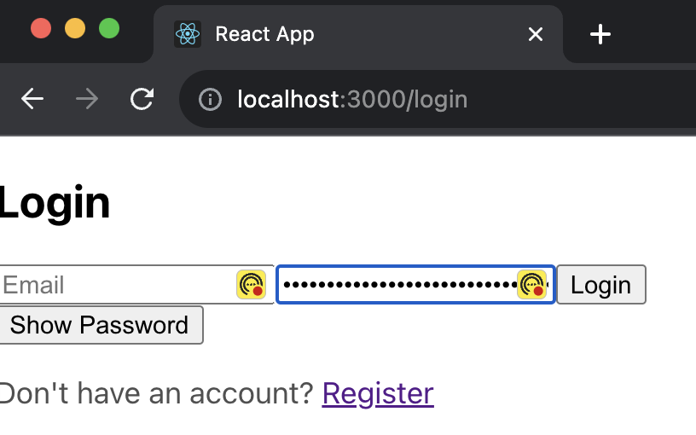

1. Consider modifying the error message when using blank/invalid inputs from “Enter valid email or password” with “Enter valid email and password” to avoid ambiguity as both email and password are needed.

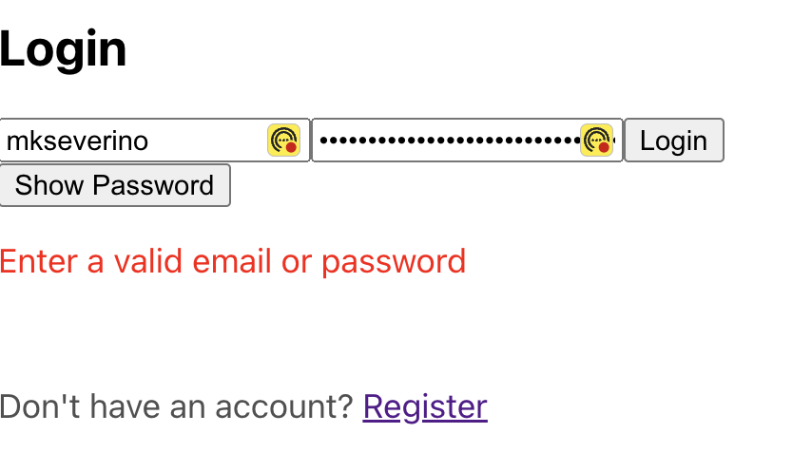

1. Given a user is logged in, it appears that this same user can access the Log In page and Sign Up page while in session. This could potentially expose security vulnerabilities as well as UX confusion. It also creates inconsistency in state management. Please refer to the State Diagram below.  
   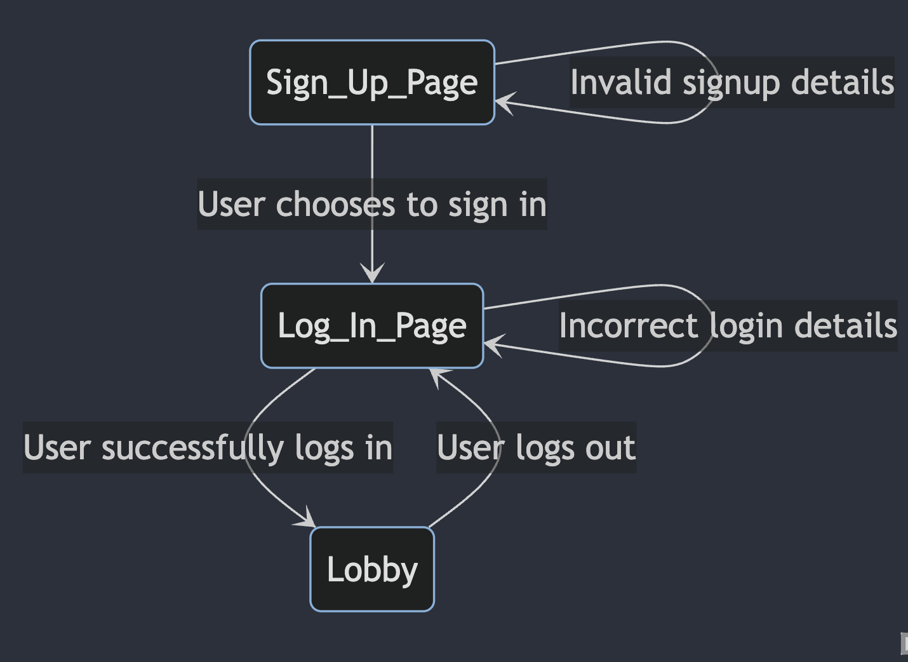
2. It appears that when not logged in, the Lobby Page url path parameter is still accessible. Although the page does not render any DOM, it is suggested to avoid access when the current browser has no session running.